Project Design Phase - II Data Flow Diagram & User Stories
Date | 4/11/25
Team ID | NM2025TMID06168
Project Name | Medical Inventory Management System
Maximum Marks | 4 Marks

Data Flow Diagram (DFD) Overview
A Data Flow Diagram (DFD) provides a clear visualization of how data moves through the Medical Inventory Management System. It highlights the interactions between users, system processes, and data stores — from input and processing to output and reporting.
In this project, the DFD represents the complete flow of operations related to medical inventory management, including supplier handling, product tracking, purchase order management, and expiry monitoring.
It demonstrates how data is collected, processed, stored, and retrieved to ensure accurate, automated, and efficient inventory control within healthcare organizations.

DFD Description
Entities and Components
- Inventory Manager / Staff:
Responsible for performing day-to-day operations such as adding new medicines, creating purchase orders, and monitoring stock levels.
- System (Salesforce Platform):
The core processing unit that automates inventory updates, validates stock and expiry data, and generates analytical reports.
- Supplier Database:
Stores detailed supplier information, contact details, delivery records, and performance metrics.
- Product Database:
Maintains data about medicines, including name, category, available stock, batch number, and expiry date.
- Purchase Order Database:
Manages all purchase order records — from creation and supplier assignment to delivery and completion status.

Process Flow
- User Interaction:
The Inventory Manager logs in to the Salesforce system and performs tasks such as adding new medicines, placing purchase orders, or checking stock availability.
- System Processing:
The system validates the input data and updates the relevant records in the connected databases.
  - Product Database: Updates stock quantity, expiry details, and product status.
  - Supplier Database: Updates supplier contact information and order history.
  - Purchase Order Database: Records purchase order creation, approval, and fulfillment details.
- Automated Actions:
  - The system triggers alerts or notifications when stock reaches a low threshold or when products are nearing expiry.
  - Validation rules ensure data integrity by preventing entry of expired or duplicate medicines.
- Report Generation:
The system compiles data from all databases to generate reports on:
  - Current stock status
  - Supplier performance
  - Pending or completed purchase orders
  - Upcoming expiries and reorder requirements
- User Feedback and Decision-Making:
The Inventory Manager reviews the generated reports and notifications to take timely actions — such as reordering medicines or following up with suppliers
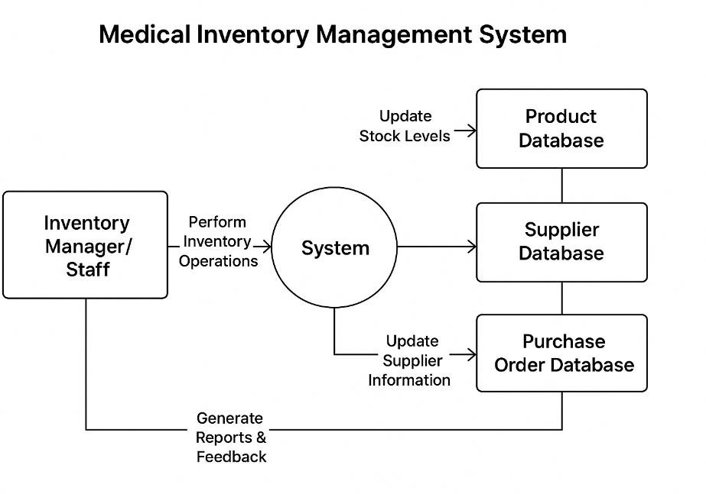

User Stories:
User stories define what different users need from the system in simple, goal-focused language. They ensure the system efficiently manages suppliers, products, purchase orders, and inventory tracking.

User Type | Functional Requirement (Epic) | User Story Number | User Story / Task | Acceptance Criteria | Priority | Release / Sprint
Inventory Manager | Supplier Management | USN-1 | As an inventory manager, I want to maintain detailed supplier information. | The system stores supplier contact info and performance metrics; allows updates and retrieval of supplier data. | High | Sprint-1
Staff | Product Catalog | USN-2 | As a staff member, I want to catalog  product details | System maintains accurate product information and  stock levels; | High | Sprint-1

User Type | Functional Requirement (Epic) | User Story Number | User Story / Task | Acceptance Criteria | Priority | Release / Sprint
 |  |  | including stock levels and descriptions. | allows updates and searches.
Inventory Supervisor | Expiry Tracking | USN-3 | As an inventory supervisor, I want to monitor product expiry dates. | System alerts users about products nearing expiry and prevents expired items from being used or dispatched. | High | Sprint-2
Procurement Officer | Purchase Order Management | USN-4 | As a procurement officer, I want to manage purchase orders efficiently. | System allows creation, update, tracking, and completion of purchase orders; reflects stock changes automatically. | Medium | Sprint-2
System Admin | Reporting | USN-5 | As a system admin, I want to generate inventory and supplier performance reports. | System generates reports showing inventory levels, purchase orders, and supplier performance accurately. | Medium | Sprint-3

